
Team Assignment 03
HIT
3/2/2012

Software Measurement and Analysis

Team members: | Members ID
Giang Thị Ha Thanh | T097828
Trần Dũng Đạt | T095716
Nguyễn Vũ Trọng Giang | T096656
Huỳnh Chấn Huy | T096498
Tạ Quang Hiệp | T090363
Nguyễn Trần Hồng Phúc | T095014

Each team presents a GQM chart for one assigned Viking project goal:
- Increase project schedule predictability by 10%
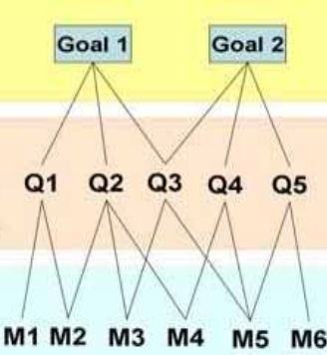
Our group was assigned to used GQM chart for the following achieved goal:
Goal: Increase project schedule predictability by 10%

To improve the estimation is accurate, it depend on hands-on experiences of previous project. In the Viking project, team uses the Matador project to compare the estimation that was increase an accurate over 10%.
To come up the question at the beginning such as: the interaction of elements to schedule, and then we can give metrics and collect necessary data.
We have three perspectives to make question:
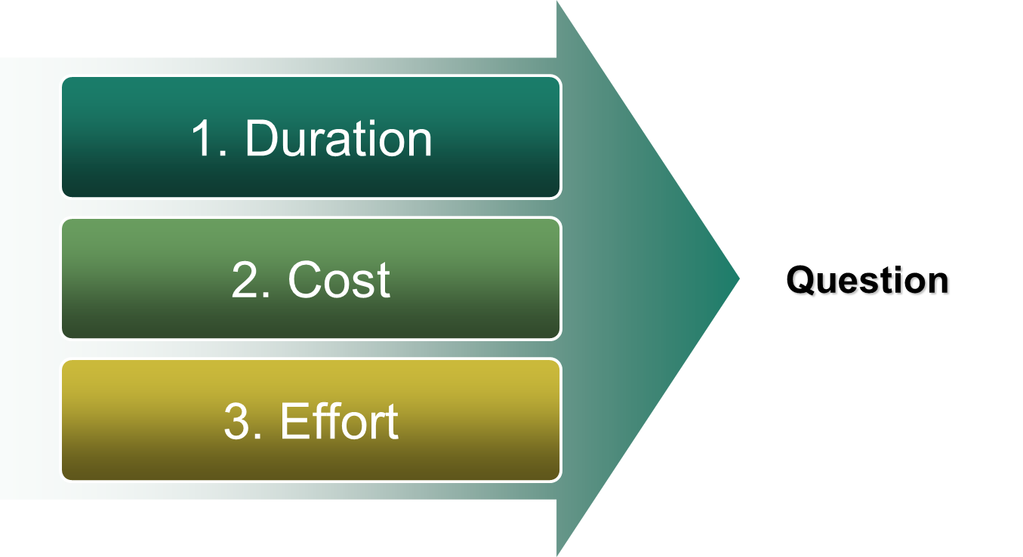
Question 1.1: What was the accuracy of Matador’s duration estimating?
Metric 1.1:
Actual duration to finish Matador: A1 (measured by days )
Estimate duration to finish Matador: E1(measured by days)
Deviation:
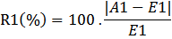
Question 1.2: What was the accuracy of Viking’s duration estimating?
Metric 1.2:
Actual duration to finish Viking: A2 (measured by days)
Estimate duration to finish Viking: E2 (measured by days)
Deviation:
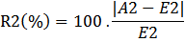

Question 1.3: What was the rate of improvement over the duration estimating of Viking project compare to previous project (Matador)?
Metric 1.3:
The prediction increases 10% when R1 - R2 >= 10% → Goal accomplished

Question 2.1: What was the accuracy of Matador’s cost estimating?
Metric 2.1:
Actual cost to finish Matador: A3 (measured by USD)
Estimate cost to finish Matador: E3(measured by USD)
Deviation:
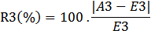

Question 2.2: What was the accuracy of Viking’s cost estimating?
Metric 2.2:
Actual cost to finish Viking: A4 (measured by USD)
Estimate cost to finish Viking: E4(measured by USD)
Deviation:
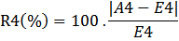

Question 2.3: What was the rate of improvement over the cost estimating of Viking project compare to previous project (Matador)?
Metric 2.3:
The prediction increases 10% when R3 - R4 >= 10% → Goal accomplished

Question 3.1: What is actual time to do specific task?
Metric 3.1
Actual time (measured by hours): Ac

Question 3.2: What was the deviation of estimate time over specific task compare with actual time in the first time?
Metric 3.2
Estimate time 1st (measured by hours): Es1
Deviation (measured by %):
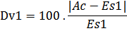

Question 3.3: What was the deviation of estimate time over specific task compare with actual time in the second time?
Metric 3.3
Estimate time 2nd (measured by hours): Es2
Deviation (measured by %):
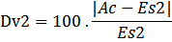

Question 3.4: What was the improvement estimating effort (compare the second time with the first time)?
Metric 3.4
The prediction increases when Dv1 - Dv2 >= 10%

